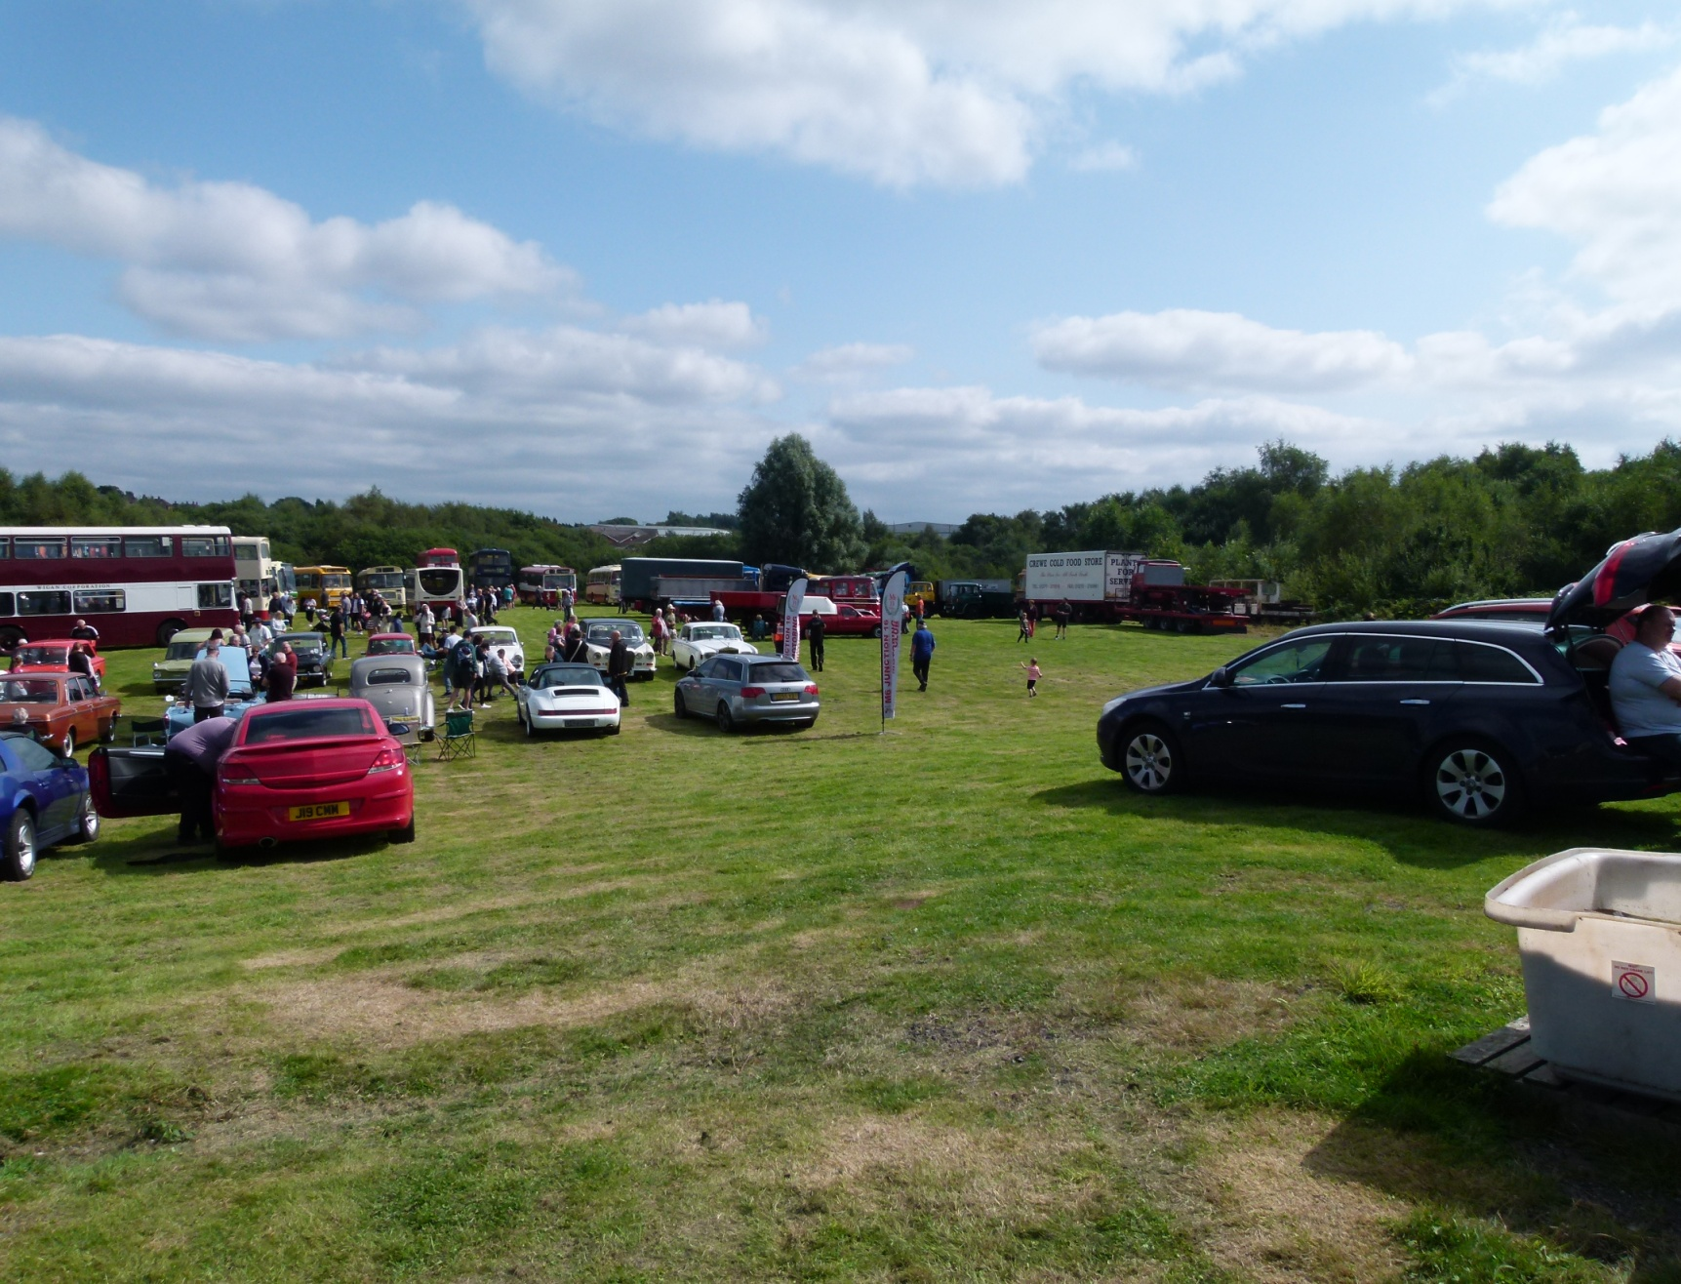
ACCESS RESTRICTIONS MEAN THAT WE CANNOT ACCOMMODATE LARGE ARTICULATED TRAILERS
IN ASSOCIATION WITH THE PMT PRESERVATION TRUST
Apedale Community Country Park, Loomer Road, Chesterton, near Newcastle under Lyme, Staffordshire, ST5 7LB
www.avlr.org.uk
MAKE.......................................... MODEL.........................................................
REG NO.............................. YEAR..........................
Name of Exhibitor..............................................................................
Address.............................................................................................
.........................................................................................................
Post Code....................... Tel No................................E-mail address…………………................
DECLARATION
I declare that I have read and understood the attached ‘Conditions of Entry’ and agree to abide by them.
I confirm that I have public liability insurance in force and that this insurance is in respect of the
vehicle/s that I am bringing to the event. The driver of the vehicle on the field (or at the event) at any
time will have a full driving licence.

Signed.................................................................

Entries to be returned to: -
Richard Grey
6, The Toppings,
Bredbury, Stockport, Cheshire
SK6 1EJ (e-mail: richarddavidgrey@tiscali.co.uk)
Apedale Valley Light Railway

Bus &Commercial Vehicle Rally

& Running Day

Sunday 10th May 2026

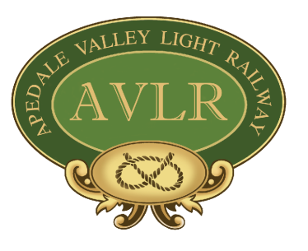
Bus & Commercial Vehicle Rally
& Running Day
Sunday 10th May 2026
Apedale Community Country Park, Loomer Road, Chesterton,
near Newcastle under Lyme, Staffordshire, ST5 7LB
www.avlr.org.uk
(Please retain this sheet for your records)

Rally - Conditions of Entry
If you have any queries regarding these, need further information, or have special requirements please do not hesitate to get in touch. We are practical people - our aim is to help not hinder.
MRT is the Moseley Railway Trust.

1. General
1.1. A steam powered exhibit that is intended to be in steam while on site must have a current boiler certificate and third party insurance cover appropriate to its function.
1.2. All stationary engines and static exhibits must have appropriate third party insurance. The organisers may, at their discretion, waive this condition for non-operating static exhibits.
1.3. Any self propelled vehicle or exhibit and driver thereof must be covered by insurance that meets the minimum requirements of the Road Traffic Act irrespective of whether the exhibit is or is not licensed for use on the public highway.
1.4. Relevant certificates must be produced when requested.

2. Stationary Engines
2.1. When in operation a Stationary Engine must be attended at all times by either the entrant or a responsible person delegated by the entrant.

3. Model Traction Engines and other Similar Vehicles
3.1. MRT will normally permit the free movement of small models around the site. Exhibitors intending to operate large models must consult with MRT prior to the event regarding the provision of suitable facilities.
3.2. Entrants/owners must ensure that their models are only driven by persons insured and competent to do so, and that they are driven in a safe and proper manner at all times.
3.3. Engines in steam must never be left unattended.

4. Cars and other Road Vehicles
4.1. Static display only, except for the programmed Running Day tours.

5. Dogs on Site
5.1. Exhibitors may have dogs with them on site provided that they are kept under control at all times and not allowed to run loose.
5.2. Dogs (other than guide dogs) are not permitted in any building.

